**A Fitting Toolbox for the impedance data obtained from inhomogeneous electrodes**

Annual Progress Seminar Report

Submitted in partial fulfilment of the requirements

for the degree of

**Doctor of Philosophy**

By

**Yugal Sharma**

Roll No. 22D1412

Supervisor

**Prof. Bharatkumar Suthar**

Co-Supervisor

**Prof. Amartya Mukhopadyay**



Department of Chemical Engineering

Indian Institute of Technology Bombay

*September 2023*

**Certificate of Acceptance**

**Department of Chemical Engineering**

**Indian Institute of Technology, Bombay**

The seminar report entitled “**A Fitting Toolbox for the impedance data obtained from inhomogeneous electrodes**” submitted by Yugal Sharma (Roll no. 22D1412) may be accepted for being evaluated.

Date: 07 Sept 2023                                                                               Prof. Bharatkumar Suthar

(Supervisor)

**Declaration**

I declare that this written submission represents my ideas in my own words and where others’ ideas or words have been included, I have adequately cited and referenced the original sources. I declare that I have properly and accurately acknowledged all sources used in the production of this report. I also declare that I have adhered to all principles of academic honesty and integrity and have not misrepresented or fabricated or falsified any idea/data/fact/source in my submission. I understand that any violation of the above will be a cause for disciplinary action by the Institute and can also evoke penal action from the sources which have thus not been properly cited or from whom proper permission has not been taken when needed.

Yugal Sharma

Date: 07 Sep 2023                                                                                    (Roll No. 22D1412)

Abstract

<Table of Contents>

**Introduction and Motivation**

The dependence on fossil fuels for energy needs is one of the most significant factors contributing to climate change, due to the emissions of $CO_{2}$ and other greenhouse gases, that are inherently involved in the combustion process of the fossil fuels. The 2015 Paris agreement International treaty has aimed to keep the global average temperature rise (compared to pre-industrial levels) below 1.5oC by the end of this century (which has already risen by 1o C by 2017). To achieve this target, it has been planned to reduced greenhouse gas emissions by 43% till 2030. Hence the need to shift towards renewable and sustainable sources of energy is urgent.

Well-studied and established renewal energy sources i.e. solar, wind, and hydro power exists, but there are problems as well with their utilization for the complete energy needs of the modern society as our energy demands have increased significantly compared to say 50 years back<put numbers in Joules or what>. The inherent problem of intermittency exists in the previous mentioned renewal energy sources, that means they may not be available all the time as per our requirement, for example the solar energy is only available as long as the sun is shining. The solution to intermittency is energy storage in some form, so that even when the source isn’t available, the energy demand can be satisfied. Energy storage technologies are based on different principles and chemistries e.g. the supercapacitors, <write more about what chemistry supercapacitor> Lead-acid batteries (used in inverters<really?>), Nickle-Metal-Hydrides, Zinc-Carbon, Lithium-ion etc., Among all, Lithium-ion batteries are superior in many fronts, as they have the highest energy density <>, power density <>, good cycle life. Making them suitable for widespread applications in consumer electronics to electric vehicles.

The Indian government and the governments worldwide<put source, specially of the Indian mission> have shown an interest to utilize Hydrogen gas as a sustainable fuel which may replace fossil fuels to a certain level<put source>. Electrochemical hydrogen fuel cells are the technology that will enable this mission.

Electrochemical Energy storage technologies are one of the best available candidates as they store the energy in a very basic form, physically possible, i.e. in form of chemical energy and which can be released as electrical energy directly. Need not to stress on the fact that most of our world today is more and more based on electrical technologies, let it be the, lights in buildings, Air conditioning, computers, in short, the exponentially growing consumer electronics demand <put nice citation><add more>, now catching up electric vehicles, but if we were to look say 100 years back, maybe mechanical form of energy was more used by the world. <write the name of such mechanical tech.>

<write more before>

***Working of Li-ion Batteries & Fuel Cells***

A lithium-ion battery is made up of several components, namely the two electrodes i.e. anode and cathode, electrolyte, separator, current collector. During charge or discharge, the Lithium-ions stored on one electrode are released from that electrode and they move towards the other electrode to get stored there, <electrolyte>. Some commonly used anode material is Graphite<>, and cathode material is LiCoO2 or NMC <full form>. The separator usually made up of glass fiber<write more>, as its name, separates/prevents the two electrodes to come in direct electrical contact, when the cell is assembled. The current collectors usually copper foil on the anode side and aluminum foil on the cathode side, facilitate double purposes, 1) the proper electric contact of the electrode with the external electric circuit and 2) as a platform to hold the electrode material. <reframe>

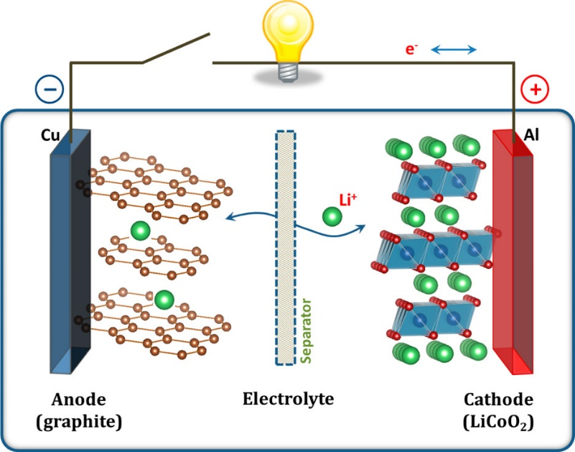

Figure 1: Schematic of the first Li-ion Battery (LiCoO2/Li+ electrolyte/graphite)1

<should I write more, what I write more>

<ask yadul for fuel cell intro, add a good diagram for fuel cells>

For both, the batteries and the fuel cells, the porous electrodes are the most important components, where the reaction-coupled transport of the species of interest occur, i.e. Lithium ion for the batteries and <> for the fuel cells. The losses/resistances related to kinetics of the charge transfer reaction ($R_{ct}$) and the losses/resistances related to the transport of ions ($R_{ion}$), are hence influenced by the characteristics of the porous electrodes. The next section discusses these characteristics of the porous electrode.

***Porous Media in electrochemical systems***

The porosity ($ε$), tortuosity ($τ$) are the parameters that geometrically characterize the porous electrodes in electrochemical systems. The $R_{ion}$ is related to the $ε$ and $τ$ as follows:

|  |  |  |
| --- | --- | --- |
|  | $$R_{ion}=d/)$$ | 1 |

<take from abhishek>

Therefore, in order to facilitate faster charging and discharging rates in batteries, it is advantageous to have reduced tortuosity values. Likewise, for the purpose of attaining increased energy density, it is favourable to aim for lower porosity values. However, achieving low tortuosity in electrodes with low porosity can be a complex endeavour due to the inverse relationship between tortuosity and porosity. Accurately ascertaining porosity and tortuosity profiles serves as a valuable tool for modelling the transport within porous materials, as exemplified by Newman-type models. This, in turn, aids in comprehending the bottlenecks that affect battery performance.

<write more here>

***Determination of the parameters of porous electrodes***

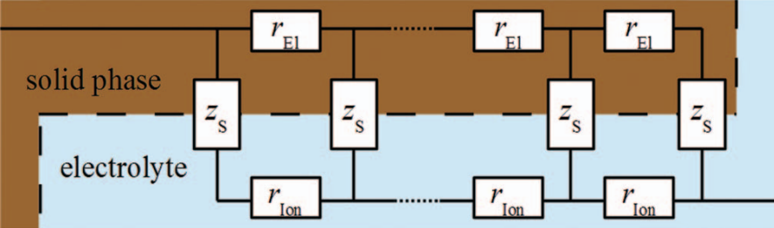Transmission line models (TLM) have been used to mathematically model the reaction-coupled transport in porous electrodes.

Figure 2: The schematic diagram of the typical transmission-line model for a porous electrode. It illustrates the charge transfer mechanism between the solid and liquid phases. This mechanism involves faradaic or capacitive charge transfer reactions and is represented by the symbol $z_{S}$. Specifically, electrons move through the solid phase (depicted in brown), while ions traverse the electrolyte phase (shown in blue).2

Electrochemical Impedance Spectroscopy (EIS) based approaches using the TLM are often used to experimentally determine the $τ$ or $C_{dl}$ of the electrode 2,3. The $ε$ of the electrode can be determined from the information about the dimensions of the electrode and the density of the electrode mixture (consisting of active material, binder and <something else>).

But these methods provide only the thickness average value of the $τ$ or $ε$ or $C_{dl}$. Hence any inhomogeneity in the $τ$, $ε$ and $C_{dl}$ is inherently ignored in these works2,3.

***Inhomogeneity in Porous media in electrochemical systems***

The non-uniform distribution of the parameters discussed above <discuss them above> across the thickness is described as “inhomogeneity” in this study. The inhomogeneity in porous media in electrochemical systems can be due to design to enhance the performance <put citation to wu et al>

Yanbo Qi et al. have performed the numerical study (considering P2D model) of the effect of using porosity as the control parameter to minimize the overall resistance of the positive electrode, comparing uniform and graded porosity electrodes, it was found that along with minimizing the overall internal resistance (compared to uniform porosity electrodes) the graded electrodes can provide opportunity to also minimize the average overpotential across the electrode, which can help to suppress the side reactions (causing the capacity fade).

Also, it has been reported that inhomogeneities can also arise from the multiple stages of manufacturing, particularly the drying process, for battery electrodes, fuel cell catalyst layers, and gas diffusion layers. In the case of catalyst layers used in fuel cells and electrolysers, the existence of a humidity gradient or ionic contamination can lead to varying levels of conductivity. <put citations> This, in turn, manifests as a gradient in transport resistance across the thickness of the porous material.

**Theory**

This section discusses the analytical models developed for in inhomogenous electrodes in the work of <basudev et al>, some theory behind fitting and contribution of present work.

Our <our or basudev et. al> recent work presents the analytical solutions for the impedance obtained from symmetric cell setup (ignoring the separator resistance) for some elementary profiles (namely, 2-step, 3-step, linear and inverse linear) of inhomogeneity in tortuosity, in the electrode. The following models for inhomogeneous electrodes were derived in our recent work. <reframe, in following text>



Figure 3: Mathematical analysis done in the work of <basudev et. al.> for the reflective setup (one half of the symmetric cell setup) considers three distinct types of inhomogeneities: a) Step-wise Inhomogeneity: This type involves a three-step profile with varying porosity, tortuosity, and double layer capacitance in each region. b) Linear Tortuosity Inhomogeneity: In this case, tortuosity varies linearly throughout the electrode's thickness, while the double layer capacitance remains constant. c) Inverse Linear Tortuosity Inhomogeneity (Effective Conductivity Variation): Here, tortuosity follows an inverse linear pattern across the electrode's thickness, while the double layer capacitance remains uniform.

For *2-step tortuosity profile* the complex impedance $Z_{2δ}$ is defined as follows:

|  |  |  |
| --- | --- | --- |
|  | $$Z_{2δ}=2×\underset{R_{ion,1}}{\underbrace{\frac{d}{πr_{0}^{2}κ_{eff,1}}}}×\frac{S_{1}C_{1}C_{2}κ_{1/2}+S_{2}}{S_{1}\left(S_{1}C_{2}κ_{1/2}+S_{2}C_{1}\right)}$$ | 2 |

Where, $C_{j}=coth⁡(δ_{j}S_{j})$, $S_{j}=√(iω/ω_{c,j})$, $ω_{c,j}=κ_{eff,j}/(d^{2}a_{j}C_{dl,j})$, $κ_{1/2 }= κ_{eff,1}/κ_{eff,2}$, and $κ_{1/3}= κ_{eff,1}/κ_{eff,3}$. Note that $\sum_{j=1}^{3}{δ_{j}}=1$. $ω_{c,j}$ can also be written as $ω_{c,j}=\frac{κ_{eff,j}\left(πr_{0}^{2}\right)}{d}×\frac{1}{d\left(πr_{0}^{2}\right)a_{j}C_{dl,j}}$ or $ω_{c,j}=1/{(R}_{ion,j}C_{Total,j})$, where $R_{ion,j} [Ω]$ is the ionic resistance of entire electrode if the entire electrode had same porosity and tortuosity as region $j$ similarly $C_{Total,j}$ [F] is the capacitance of entire electrode if the entire electrode had same specific area and double layer capacitance as region $j$. One must be careful in interpreting the $R_{ion,j}$ and $C_{Total,j}$. ${δ_{j}R}_{ion,j}$ and $δ_{j}C_{Total,j}$ are the ionic resistance and the capacitance of the $j^{th}$ region.

Expressing $ω_{c,j}$ in terms of $R_{ion,j}$ and $C_{Total,j}$ facilitates the derivation of impedance solutions for a non-ideal capacitor, often represented as a constant phase element. To accommodate this constant phase element, it is necessary to revise the definition of $S_{j}$, which can be updated as follows: $S_{j,α}=\sqrt{{\left(ιω\right)}^{α}/ω_{Q,j}}$ where $α$ (dimensionless) represents the constant phase exponent, and $ω_{Q,j}=1/{(R}_{ion,j}Q_{j})$. In this context, $Q_{j}$ $[{Fs}^{1-α}]$ serves as the parameter associated with the electrode capacitance within the $j^{th}$ region.

For *3-step tortuosity profile* <write it gives>

|  |  |  |
| --- | --- | --- |
|  | $$Z_{3δ}=2\underset{R_{ion,1}}{\underbrace{\frac{d}{πr_{0}^{2}κ_{eff,1}}}}×\frac{S_{1}S_{3}C_{1}κ_{1/2}^{2}+S_{2}C_{2}\left(S_{1}C_{1}C_{3}κ_{1/3}+S_{3}\right)κ_{1/2}+S_{2}^{2}C_{3}κ_{1/3}}{S_{1}\left(S_{3}{S_{1}κ}_{1/2}^{2}+S_{2}C_{2}\left(S_{3}C_{1}+{S_{1}C}_{3}κ_{1/3}\right)κ_{1/2}+S_{2}^{2}C_{1}C_{3}κ_{1/3}\right)}$$ | 3 |

For *linear tortuosity profile* <write something>

|  |  |  |
| --- | --- | --- |
|  | $$Z_{lin}=2\underset{R_{ion,1}}{\underbrace{\underset{R_{ref}}{\underbrace{\frac{d}{πr_{0}^{2}κε }}}τ_{lin,1}}}×\frac{1}{S_{1}}\frac{I_{\frac{1}{3}}\left(-\frac{2}{3}\frac{τ_{1/2}^{-\frac{1}{2}}S_{1}}{τ_{1/2}-1}\right)I_{\frac{2}{3}}\left(-\frac{2}{3}\frac{τ_{1/2} S_{1}}{τ_{1/2}-1}\right)-I_{-\frac{2}{3}}\left(-\frac{2}{3}\frac{τ_{1/2} S_{1}}{τ_{1/2}-1}\right)I_{-\frac{1}{3}}\left(-\frac{2}{3}\frac{τ_{1/2}^{-\frac{1}{2}}S_{1}}{\left(τ_{1/2}-1\right)}\right)}{I_{\frac{1}{3}}\left(-\frac{2}{3}\frac{τ_{1/2} S_{1}}{τ_{1/2}-1}\right)I_{-\frac{1}{3}}\left(-\frac{2}{3}\frac{τ_{1/2}^{-\frac{1}{2}}S_{1}}{τ_{1/2}-1}\right)-I_{\frac{1}{3}}\left(-\frac{2}{3}\frac{τ_{1/2}^{-\frac{1}{2}}S_{1}}{τ_{1/2}-1}\right)I_{-\frac{1}{3}}\left(-\frac{2}{3}\frac{τ_{1/2} S_{1}}{τ_{1/2}-1}\right)}$$ | 4 |

$I_{γ}$ is the modified Bessel function of the first kind with $γ$ as a fraction, $S_{1}=\sqrt{ιω/ω_{c,1}}$, $ω_{c,1}={κ_{eff,1}}/{\left(aC_{dl }d^{2}\right)}$, $κ_{eff,1}=κε/τ_{lin,1}$, $τ_{1/2}=τ_{lin,1}/τ_{lin,2}$. To account for the constant phase element, the definition of $S$ needs to be updated as $S_{1,α}=\sqrt{{\left(ιω\right)}^{α}/ω_{Q,1}}$, where $ω_{Q,1}=1/{(R}_{ion,1}Q)$. Here $R_{ion,1}(=d/(κ_{eff,1}πr_{0}^{2}) =R_{ref}×τ_{lin,1})$ is the ionic resistance of the disk assuming $τ_{lin,1}$ as the tortuosity of the whole electrode.

<write about apparent resistance>

For *Inverse-linear tortuosity profile* or the *linear conductivity profile* as <tau =1/kappa>

|  |  |  |
| --- | --- | --- |
|  | $$Z_{ilin}=2\underset{R_{ion,1}}{\underbrace{\underset{R_{ref}}{\underbrace{\frac{d}{πr_{0}^{2}κε }}}τ_{ilin,1}}}×\frac{ι}{S_{1}}\frac{Y_{1}\left(-\frac{2ιτ_{1/2}S_{2}}{τ_{1/2}-1}\right)J_{0}\left(-\frac{2ιS_{1}}{τ_{1/2}-1}\right)-J_{1}\left(-\frac{2ιτ_{1/2}S_{2}}{τ_{1/2}-1}\right)Y_{0}\left(-\frac{2ιS_{1}}{τ_{1/2}-1}\right)}{J_{1}\left(-\frac{2ιτ_{1/2}S_{2}}{τ_{1/2}-1}\right)Y_{1}\left(-\frac{2ιS_{1}}{τ_{1/2}-1}\right)-Y_{1}\left(-\frac{2ιτ_{1/2}S_{2}}{τ_{1/2}-1}\right)J_{1}\left(-\frac{2ιS_{1}}{τ_{1/2}-1}\right)}$$ | 5 |

$J_{γ}$ represents the Bessel function of the first kind, while $Y_{γ}$ denotes the Bessel function of the second kind, with γ being a fractional value. $S_{j}=\sqrt{ιω/ω_{c,j}}$, where $ω_{c,j}={κ_{eff,j}}/{\left(aC_{dl }d^{2}\right)}$, and $κ_{eff,j}=κε/τ_{ilin,j}$. $τ_{1/2}=τ_{ilin,1}/τ_{ilin,2}$

<mention the perturbation and semi-infinite later in formulation>

***Reformulation of the models***

To reduce the <why do we reformulate model> number of parameters need to be optimized, and combine

<write more>

<write about Q and alpha>

<something>

|  |  |  |
| --- | --- | --- |
|  | $$Z_{2δ}=2R_{ion,1}×\frac{S_{1}C_{1}C_{2}κ_{1/2}+S_{2}}{S_{1}\left(S_{1}C_{2}κ_{1/2}+S_{2}C_{1}\right)}$$ | 6 |

$κ_{1/2}=\frac{R_{ion,2}}{R_{ion,1}}$

$Q$ is normalized with $1e-3$ because <what’s the reason of normalizing>

Combining $R_{ion}$ and Q as done in EC-lab

***Construction of the Complex Non-linear Least Squares (CNLS) minimization problem***

As can be seen, all the models Eqn. <cite equations this this and rthis>, the impedance has a highly non-linear dependence on the model parameters. And hence to obtain the model parameters from the experimental data, we need to formulate the CNLS optimization problem, using the experimental data from the impedance spectroscopy and the data predicted using the assumed model. <reframe>

The general problem of data fitting often involves minimizing the sum of square of errors $χ^{2}$, which in our case is written as follows <re-write>

|  |  |  |
| --- | --- | --- |
|  | $$χ^{2}=\sum_{i=1}^{N}{{w_{i}^{'}\left(Z_{i, exp}^{'}-Z_{i, model}^{'}\right)}^{2}+{w_{i}^{''}\left(Z_{i,exp}^{''}-Z_{i,model}^{''}\right)}^{2}}$$ | 7 |

Where, $N$ is the number of experimental data points (each obtained at different frequency). $Z_{i}^{'}$ and $Z_{i}^{''}$ are respectively the real and imaginary part of the impedance obtained from the model and the experiment for the $i$ th data point (corresponding to $i$ th frequency $ω_{i}$), $w_{i}^{'}$ and $w_{i}^{''}$ are the respective weights associated with the error for the real and the imaginary part of impedance for the $i$ th data point, that corresponds to $i$ th frequency.

$Z_{model}$ outputs the impedance by taking $ω$ as the input along with the model parameters say

|  |  |  |
| --- | --- | --- |
|  |  | 8 |

Hence the only unknowns in the Eqn. 7 <cite the equation> are the model parameters i.e. $p_{0},p_{1}…p_{n}$

And the $χ^{2}$ is a function of only $p_{0},p_{1}…p_{n}$

|  |  |  |
| --- | --- | --- |
|  | $$χ^{2}=χ^{2}(p_{0},p_{1}…p_{n})$$ | 9 |

The statement for the minimization problem can then be written as,

|  |  |  |
| --- | --- | --- |
|  | $${min \atop p∈R^{n}}{ χ}^{2}\left(p\right)$$ | 10 |

Subject to the inequality constraints $c(p)$ coming from the user provided upper and lower bounds on the model parameters, written as,

|  |  |  |
| --- | --- | --- |
|  | $$c\left(p\right)≥0$$ | 11 |

Where $a$ represents the vector consisting of $n$ model parameters

***Model Specific construction of CNLS optimization problem***

**<make above a heading good one>**

*Two-step case-*

The $χ^{2}$ function can be written as,

|  |  |  |
| --- | --- | --- |
|  | $$χ^{2}=\sum_{i=1}^{N}{{w_{i}^{'}\left(Z_{i, exp}^{'}-Z_{i, 2δ}^{'}\right)}^{2}+{w_{i}^{''}\left(Z_{i,exp}^{''}-Z_{i,2δ}^{''}\right)}^{2}}$$ | 12 |

For the *Three-step case*, it can be written as,

|  |  |  |
| --- | --- | --- |
|  | $$χ^{2}=\sum_{i=1}^{N}{{w_{i}^{'}\left(Z_{i, exp}^{'}-Z_{i, 3δ}^{'}\right)}^{2}+{w_{i}^{''}\left(Z_{i,exp}^{''}-Z_{i,3δ}^{''}\right)}^{2}}$$ | 13 |

For the Linear and Inverse-Linear case, simulating the frequency response expressions (Eqn. 3 and 4) within a finite domain can lead to numerical inaccuracies when dealing with higher frequencies ($ω≫ω_{c}$). This issue becomes more pronounced when the tortuosity inhomogeneity diminishes, where the term involving the tortuosity ratio ($τ_{12}$ or $τ_{lin,1}/τ_{lin,2}$) in the $(τ_{12}-1)→0$ as the tortuosity profile becomes more uniform. In such scenarios, achieving precise results with the analytical solutions (Eqn. 3 and 4) for the finite domain necessitates the use of high-precision computation methods. Figure 3 in the work of <basudev et. al.> illustrates the demand for high-precision arithmetic in the case of a nearly flat linear tortuosity profile simulated using Eqn. 3, where even a 60-digit accurate floating-point implementation (utilizing variable precision arithmetic in MATLAB) proves insufficient for accurately reproducing the impedance response (as evidenced by the blue-dotted curve at higher frequencies).



<decide about caption>

<generate figure from my own plot and code>

Hence <Choudhury et. al.> have derived expression for the semi-infinite domain for both the linear and the inverse-linear tortuosity variation to handle the high-frequency behavior without the need for high precision arithmetic, also they have used perturbation theory to develop expressions which can capture the impedance response of a near-flat linear tortuosity profile.

The expressions for the semi-infinite domain and the perturbation theory-based solutions are described below.

|  |  |  |
| --- | --- | --- |
|  | $$Z_{lin,semi}=2\underset{R_{ion,1}}{\underbrace{\underset{R_{ref}}{\underbrace{\frac{d}{πr_{0}^{2}κε}}}τ_{lin,1}}}\frac{1}{S_{1}}×\frac{I_{-\frac{2}{3}}\left(-\frac{2}{3}\frac{τ_{1/2}S_{1}}{τ_{12}-1}\right)-I_{\frac{2}{3}}\left(-\frac{2}{3}\frac{τ_{1/2}S_{1}}{τ_{1/2}-1}\right)}{I_{-\frac{1}{3}}\left(-\frac{2}{3}\frac{τ_{1/2}S_{1}}{τ_{1/2}-1}\right)-I_{\frac{1}{3}}\left(-\frac{2}{3}\frac{τ_{1/2}S_{1}}{τ_{1/2}-1}\right)}$$ | 14 |
|  | $$Z_{ilin,semi}=2\underset{R_{ion,1}}{\underbrace{\underset{R_{ref}}{\underbrace{\frac{d}{πr_{0}^{2}κε }}}τ_{lin,1}}×}\frac{ι}{S_{1}}\left(\frac{\left(\sqrt{1+ι}\right)J_{0}\left(\frac{-2ιS_{1}}{τ_{\frac{1}{2}}-1}\right)+\left(\sqrt{-1-ι}\right)Y_{0}\left(\frac{-2ιS_{1}}{τ_{\frac{1}{2}}-1}\right)}{\left(\sqrt{1+ι}\right)J_{1}\left(\frac{-2ιS_{1}}{τ_{\frac{1}{2}}-1}\right)+\left(\sqrt{-1-ι}\right)Y_{1}\left(\frac{-2ιS_{1}}{τ_{\frac{1}{2}}-1}\right)}\right)$$ | 15 |

<ilin semi doesn’t offer such advantage of numerical stabilization at higher frequencies, why?>

The perturbation theory-based approximate solutions for the linear and inverse-linear tortuosity profiles are described below.

|  |  |  |
| --- | --- | --- |
|  | $$Z_{lin,pert}=2\underset{R_{ion,1}}{\underbrace{\underset{R_{ref}}{\underbrace{\frac{d}{πr_{0}^{2}κε }}}τ_{lin,1}}}×\frac{{\left({\text{e}}^{2 S_{1}}+1\right)}^{2}}{ \left(ϵ\left(S_{1}^{2}+\frac{1}{2}\right){\text{e}}^{2S_{1}}+\left(-\frac{ϵ}{4}+S_{1}\right){\text{e}}^{4 S_{1}}-\frac{ϵ}{4}-S_{1}\right)}$$ | 16 |

|  |  |  |
| --- | --- | --- |
|  |  | 17 |

Where $ϵ≡\frac{\left(τ_{lin,2}-τ_{lin,1}\right)}{τ_{lin, 1}}$ <and other stuff>

The $χ^{2}$ function can be written as following for the *linear case* as follows

|  |  |  |
| --- | --- | --- |
|  | $$χ^{2}= {\sum_{i=1}^{N=n_{ω^{'}}}{{{ w}_{i}^{'}\left(Z_{i, exp}^{'}-Z_{i, lin}^{'}\right)}^{2}+{w_{i}^{''}\left(Z_{i,exp}^{''}-Z_{i,lin}^{''}\right)}^{2}} \atop \begin{aligned}+ \\ \left\{\begin{aligned}\sum_{i=n_{ω^{'}}+1}^{N}{{{ w}_{i}^{'}\left(Z_{i, exp}^{'}-Z_{i, lin,semi}^{'}\right)}^{2}+{w_{i}^{''}\left(Z_{i,exp}^{''}-Z_{i,lin,semi}^{''}\right)}^{2} ,if ϵ≤ϵ_{c}} \\ or \\ \sum_{i=n_{ω^{'}}+1}^{N}{{{ w}_{i}^{'}\left(Z_{i, exp}^{'}-Z_{i, lin,pert}^{'}\right)}^{2}+{w_{i}^{''}\left(Z_{i,exp}^{''}-Z_{i,lin,pert}^{''}\right)}^{2}} ,if ϵ>ϵ_{c}\end{aligned}\right.\end{aligned}}$$ | 18 |

<bold the plus>

Where $n_{ω^{'}}$ is the choosen data point with the frequency $ω^{'}$, such that $ω^{'}<<ω_{c}$, and the $Z_{lin}$ expression for impedance of linear profile, may result in inaccuracies at $ω>ω^{'}$, at lower precision computing, hence $Z_{lin,semi}$ expression need to be used to find the impedance at $ω>ω^{'}$,. And $ϵ_{c}$ is the critical value of $(τ_{12}-1)$, after which the inaccuracies at $ω>ω^{'}$ become more profound, at loweer precision computing, hence $Z_{lin,pert}$ expression need to used, which can approximate the full analytical solution $Z_{lin}$ in these conditions.

For Inverse-linear case the $χ^{2}$ objective function becomes,

|  |  |
| --- | --- |
| $$χ^{2}= {\sum_{i=1}^{N=n_{ω^{'}}}{{{ w}_{i}^{'}\left(Z_{i, exp}^{'}-Z_{i, lin}^{'}\right)}^{2}+{w_{i}^{''}\left(Z_{i,exp}^{''}-Z_{i,lin}^{''}\right)}^{2}} \atop \begin{aligned}+ \\ \left\{\begin{aligned}\sum_{i=n_{ω^{'}}+1}^{N}{{{ w}_{i}^{'}\left(Z_{i, exp}^{'}-Z_{i, ilin,semi}^{'}\right)}^{2}+{w_{i}^{''}\left(Z_{i,exp}^{''}-Z_{i,ilin,semi}^{''}\right)}^{2} ,if ϵ≤ϵ_{c}} \\ or \\ \sum_{i=n_{ω^{'}}+1}^{N}{{{ w}_{i}^{'}\left(Z_{i, exp}^{'}-Z_{i, ilin,pert}^{'}\right)}^{2}+{w_{i}^{''}\left(Z_{i,exp}^{''}-Z_{i,ilin,pert}^{''}\right)}^{2}} ,if ϵ>ϵ_{c}\end{aligned}\right.\end{aligned}}$$ | 19 |

<it is not the same thing>

**Weighing Methods**

In the model specific equations above for $χ^{2}$, the $w_{i}^{'}$ and $w_{i}^{''}$ are the respective weights associated with the error for the real and the imaginary part of impedance for the $i$ th data point. Lasia <citation here> have described following methods for weighing, <write for importance of weighint>

1) Statistical weighting:

|  |  |  |
| --- | --- | --- |
|  | $w_{i}^{'}=\frac{1}{{\left(σ_{i}^{'}\right)}^{2}}$ and $w_{i}^{''}=\frac{1}{{\left(σ_{i}^{''}\right)}^{2}}$ | 20 |

Where $σ_{i}$ is the standard deviation associated with the $i^{th}$ data point. To calculate the $σ_{i}$, it is necessary to collect impedance data repeatedly and subsequently compute separate standard deviations for the real and imaginary components. These calculations should be based on the average impedance recorded at each frequency. However, being a straightforward to understand method it has practical drawbacks, clearly it will be time consuming and second, that the impedances may gradually vary with time and hence extra systematic error will be added to the average impedance frequency at each point

2) Unit weighting:

|  |  |  |
| --- | --- | --- |
|  | $$w_{i}^{'}=w_{i}^{''}=1$$ | 21 |

An equal weightage is given to all the data points. Drawbacks of this method may appear in complicated models where the values of impedances at different frequencies vary by orders of magnitude and using this method there may provide more weightage to the larger impedances (hence with larger absolute errors) and the data points with smaller frequencies may be ignored.

3) Modulus weighting:

|  |  |  |
| --- | --- | --- |
|  |  | 22 |

Modulus weighting presupposes that both the real and imaginary components carry identical statistical weights, and these weights are in direct proportion to the impedance modulus. In practical terms, this implies that both small and large impedances make comparable contributions to the sum of squares and hold equal significance in the analysis.

There are two choices to apply modulus weighing, one based on modulus of the experimental data and the other based on the modulus of the data from model.

|  |  |  |
| --- | --- | --- |
|  | or | 23 |

4) Proportional weighting:

This method is especially important when the real and imaginary components have much different values. As in the case of modulus weighing, here also we can defined the weights either based on experimental data or the model. But it is suggested <why read paper> to use model based data.

|  |  |  |
| --- | --- | --- |
|  | $w_{i}^{'}=\frac{1}{{\left(Z_{i}^{'}\right)}^{2}}$ and $w_{i}^{''}=\frac{1}{{\left(Z_{i}^{''}\right)}^{2}}$ | 24 |

**Model specific constraints**

For *Two step case*

*<*see the method of writing constraints in optimization*>*

<need to do reformulation first>

|  |  |  |  |
| --- | --- | --- | --- |
|  | $$δ_{1}≤1$$ | 25 | |
|  | $$R_{ion,1},R_{ion,2},Q>0$$ | 26 |

*Three step case*

|  |  |  |
| --- | --- | --- |
|  | $$δ_{j=1,2}≤1$$ | 27 |
|  | $$R_{ion,1},R_{ion,2},R_{ion,3},Q>0$$ | 28 |

<equal to will come or not>

*Linear case*

*Inverse linear case*

**Methods for solution of the CNLS minimization problem**

General methods used for the general non-linear optimization problems can be applied to CNLS minimization problem as well. Specially for the data fitting, Levenberg-Marquardt type of methods are also popular <JJ more citation>. <write more> But we have used a Trust-Region based method <citation to Nocedal>for the solution of above mentioned CNLS minimization problem, with constraints as mentioned in section just above.

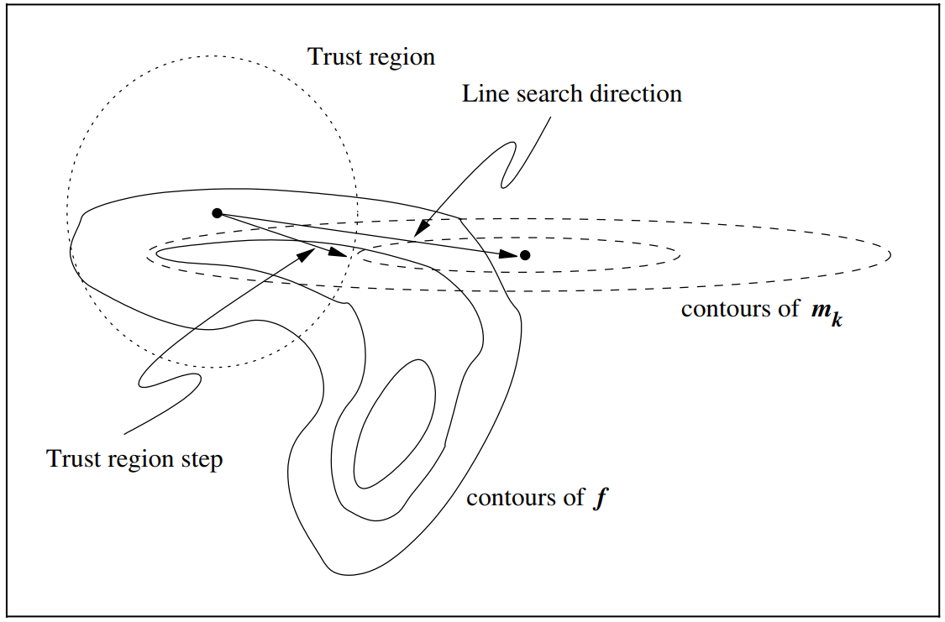

Figure : An illustration of the comparison of Trust-region methods with line search methods<Nocedal citation>

The following steps describe in brief the algorithm of a general trust region method:

1. Take an initial guess about the values of $p$
2. <write about trust region algo in brief>

**Problem and Model specific modifications**

We want to use proportional weighing because the imaginary part is always orders of magnitude higher than the real part of impedance in our models, at lower frequencies, hence to provide equal weightage to both the imaginary and real part during fitting, proportional weighing is choosen, more is described about proportional weighing in the section on weighing methods above <need reference there>

Results and discussion

<This expression below should come in the discussion>

|  |  |  |
| --- | --- | --- |
|  | $$τ_{app,2τ}=τ_{1}\left(1-β_{1}^{3}\right)+β_{1}^{3}τ_{2}$$ | 29 |

<We don’t directly get tau1 tau2, we get R1 and R2 and from there we can get by Rref that is known>

List of Symbols

<remove some from here>

|  |  |  |
| --- | --- | --- |
| **Symbol** | **Description** | **Unit** |
| $$A$$ | Cross section area of the disk-shaped electrode ($πr_{o}^{2}$) | $$m^{2}$$ |
| $$a$$ | Specific particle surface area providing double-layer capacitance | $$m_{BET}^{2}/m^{3}$$ |
| $$C_{dl}$$ | Areal double layer capacitance | $$F/m_{BET}^{2}$$ |
| $$C_{Total}$$ | Capacitance of entire electrode | $$F$$ |
| $d$ | Thickness of electrode | $m$ |
| $ι$ | Imaginary unit $\left(\sqrt{-1}\right)$ | $-$ |
| $$i$$ | Complex ionic current | $$A$$ |
| $i_{dl}$ | Complex current density | $$A$$ |
| $L$ | Low-frequency intercept | $$Ω$$ |
| $N_{m}$ | MacMullin number | $-$ |
| $$p$$ | The model parameter/ vector containing the model parameters | $$-$$ |
| $Q$ | Parameter related to electrode capacitance | ${Fs}^{1-α}$ |
| $r_{0}$ | Radius of the porous electrode disk | $m$ |
| $$R_{ion}$$ | Ionic resistance of entire electrode | $$Ω$$ |
| $R_{ref}$ | Ionic resistance of single electrode disk assuming tortuosity of 1 | $$Ω$$ |
| $t$ | Time | $s$ |
| $x$ | Axial coordinate across the thickness of the electrode | $m$ |
| $$Z$$ | Complex impedance | $Ω$ |
| $$N$$ | Total number of experimental data points | _ |
| **Greek** | | |  |  |
| $$α$$ | Constant phase exponent | $-$ |
| $$β$$ | Scaled axial coordinate | $-$ |
| $$δ$$ | Thickness fraction | $-$ |
| $$ϵ,ϵ'$$ | Perturbation parameter | $$-$$ |
| $$ε$$ | Porosity | $-$ |
| $$κ$$ | Bulk/intrinsic electrolyte conductivity | $mS/cm$ |
| $$κ_{eff}$$ | Effective conductivity of the electrolyte | $mS/cm$ |
| $$ϕ$$ | Electrolyte potential | $V$ |
| $$Φ$$ | Complex electrolyte phase potential | $V$ |
| $$Φ_{solid}$$ | Complex solid phase potential | $V$ |
| $$τ$$ | Tortuosity | $-$ |
| $$ω$$ | Angular frequency | $rad/s$ |
| $$ω_{c}$$ | Characteristic frequency | $$rad/s$$ |
| $$ω_{Q}$$ | Characteristic frequency, accounting for constant phase element | $$rad/s$$ |
| $$ω_{t}$$ | Angular turning frequency ($-Im\left(Z\left(ω_{t}\right)\right)=LFR-HFR$), where *LFR* and *HFR* are low- and high-frequency resistances respectively | $rad/s$ |
| $$ζ$$ | Scaled axial coordinate $(≡x/d)$ | $-$ |

**Repeated Subscripts**

|  |  |
| --- | --- |
| **Symbol** | **Description** |
| $$app$$ | Related to apparent tortuosity |
| $$c$$ | Related to characteristic frequency considering ideal double-layer capacitance |
| ilin | Related to the inverse linear tortuosity inhomogeneity |
| $$j$$ | Step-wise profile: $j=$ $1$, $2$ and $3$ represents the three regions  Linear and inverse-linear: $j=$ $1$ and $2$ represents the near separator side and near the current collector side |
| $$j/j’$$ | Ratio of properties at two locations or for two regions |
| $$lin$$ | Related to the linear tortuosity inhomogeneity |
| $$nτ$$ | $n=2,3$, related to $2$ step or $3$ step tortuosity in the electrode |
| $$nδ$$ | $n=2,3$, related to $2$ step or $3$ step inhomogeneity in the electrode |
| pert | Related to the perturbation method-based solutions |
| $$Q$$ | Related to characteristic frequency considering constant phase element |
| semi | Related to semi-infinite domain solutions |
| $$t$$ | Related to the turning frequency |
| $$Total$$ | Representing the entire electrode |
| uni | Related to the uniform electrode |

References

1. J. B. Goodenough and K.-S. Park, *J Am Chem Soc*, **135**, 1167–1176 (2013).

2. J. Landesfeind, J. Hattendorff, A. Ehrl, W. A. Wall, and H. A. Gasteiger, *J Electrochem Soc*, **163**, A1373–A1387 (2016) https://iopscience.iop.org/article/10.1149/2.1141607jes.

3. N. Ogihara et al., *J Electrochem Soc*, **159**, A1034–A1039 (2012).

Things to be done in report extra

<bold and stuff>